Project Planning Phase
Sprint Delivery Planning
Date | 18 October 2022
Team ID | PNT2022TMID28577
Project Name | Predicting the energy output of wind turbine based on weather condition
Maximum Marks | 8 Marks
Product Backlog, Sprint Schedule, and Estimation (4 Marks)
Sprint | Functional  Requirement (Epic) | User Story  Number | User Story / Task | Story Points | Priority | Team  Members
Sprint-1 | Registration | USN-1 | As a user, I can register for the application by entering my email, password, and confirming my password. | 5 | High | Sathish kumar M  Samuvel S  Radhika V  Sneha V  Arthi M
Sprint-1 |  | USN-2 | As a user, I will receive confirmation email once I have registered for the application | 5 | High | Sathish kumar M  Samuvel S  Radhika V  Sneha V  Arthi M
Sprint-1 |  | USN-3 | As a user, I can register for the application using phone number | 2 | Low | Sathish kumar M  Samuvel S  Radhika V  Sneha V  Arthi M
Sprint-1 |  | USN-4 | As a user, I can register for the application through Gmail | 3 | Medium | Sathish kumar M  Samuvel S  Radhika V  Sneha V  Arthi M
Sprint-1 | Login | USN-5 | As a user, I can log into the application by entering email & password | 5 | High | Sathish kumar M  Samuvel S  Radhika V  Sneha V  Arthi M

Sprint | Functional  Requirement (Epic) | User Story  Number | User Story / Task | Story Points | Priority | Team  Members
Sprint-2 | Dashboard | USN-6 | Once I have logged in, I can see my dashboard. | 6 | Medium | Sathish kumar M  Samuvel S  Radhika V  Sneha V  Arthi M
Sprint-2 | Web Access | USN-7 | As a customer I can access the website to predict the turbine power. | 7 | High | Sathish kumar M  Samuvel S  Radhika V  Sneha V  Arthi M
Sprint-2 | Prediction | USN-8 | As a customer when I enter the weather details the website should predict the approximate turbine power. | 7 | High | Sathish kumar M  Samuvel S  Radhika V  Sneha V  Arthi M
Sprint-3 | Analysis | USN-9 | As a customer, I wish to store my predictions and make analyses. | 10 | Medium | Sathish kumar M  Samuvel S  Radhika V  Sneha V  Arthi M
Sprint-3 | Security | USN-10 | As a customer I expect my data to be secured. | 10 | Medium | Sathish kumar M  Samuvel S  Radhika V  Sneha V  Arthi M
Sprint-4 | Database Access | USN-11 | As an administrator, I should maintain the website and update the website regularly. | 20 | Low | Sathish kumar M  Samuvel S  Radhika V  Sneha V  Arthi M
Project Tracker, Velocity & Burndown Chart: (4 Marks)
Sprint | Total Story Points | Duration | Sprint Start Date | Sprint End Date (Planned) | Story Points  Completed (as on  Planned End Date) | Sprint Release Date (Actual)
Sprint-1 | 20 | 6 Days | 24 Oct 2022 | 29 Oct 2022
Sprint-2 | 20 | 6 Days | 31 Oct 2022 | 05 Nov 2022
Sprint-3 | 20 | 6 Days | 07 Nov 2022 | 12 Nov 2022
Sprint-4 | 20 | 6 Days | 14 Nov 2022 | 19 Nov 2022
Velocity:
Imagine we have a 10-day sprint duration, and the velocity of the team is 20 (points per sprint). Let’s calculate the team’s average velocity (AV) per iteration unit (story points per day)
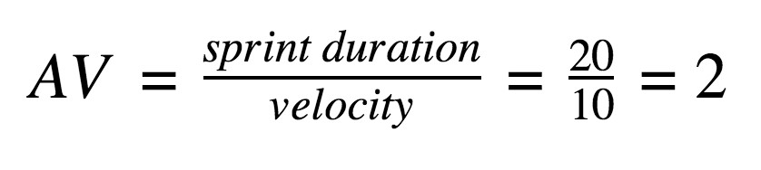
Burndown Chart:
A burndown chart is a graphical representation of work left to do versus time. It is often used in agile software development methodologies such as Scrum. However, burn down charts can be applied to any project containing measurable progress over time.
https://www.visual-paradigm.com/scrum/scrum-burndown-chart/ https://www.atlassian.com/agile/tutorials/burndown-charts
Reference: https://www.atlassian.com/agile/project-management
https://www.atlassian.com/agile/tutorials/how-to-do-scrum-with-jira-software https://www.atlassian.com/agile/tutorials/epics https://www.atlassian.com/agile/tutorials/sprints https://www.atlassian.com/agile/project-management/estimation https://www.atlassian.com/agile/tutorials/burndown-charts

